Read me
1-Unrar EGOUT2023.rar
2-Goto Folder of EGOUT2023 and Run Setup.exe
3-Make New folder (EGOUT) in other Drives of Hard disk
4- Copy EGOUT2023 in new folder (EGOUT)

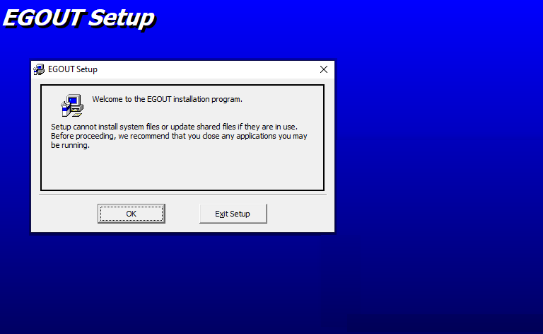
For use and write of files change folder of (C:\) to other Drives
