1- How the EGOUT program works
Before starting to work with the program, its operation is explained. (The detailed information below is for explaining how the program works and will be fully and practically explained in later sections)
The EGOUT program is a sewer network design tool that works in the AutoCAD environment. It identifies, sorts and analyzes the drafted sewer network plan, attaches hydraulic information to it, and makes the network data solvable and analyzable.
1- The program links with AutoCAD. (START)
2- The sewer lines drawn in the SEWER layer are considered as network pipes.
3- The start and end points of each pipe are considered as manholes.
4- It acts intelligently in network identification:

4-1- By introducing the sewer network outlet point(s) by installing the end block at the end of the network outlet line, the program identifies and sorts the network lines starting from the outlet(s). If a pipe is not connected to the outlet path(s), it will report an error.

4-2- Considering the network path identification process by the program, no drawing order or rule is required. The drawn lines just need to be end to end in the sewer layer using the line command in AutoCAD.

4-3- The program identifies the lines connected to the outlet path(s) by EDIT and sorts them towards it (the line direction will be towards the outlet, meaning the start point of the drawn line will be considered the beginning and the end point of the drawn line will be considered the end).

4-4- To facilitate error tracking in network drafting, the program draws the error lines from the beginning of the related line to the center of the EGOUT mark on the map and shows them in the error layer with specific colors.

4-5- An attached table of extended data is added to each pipe by the program. The program completes the attached table during the map preparation process.

5- Naming the Laterals (each lateral or branch has several interconnected pipes that are defined as main, semi-main, and secondary relative to each other. Branch coloring is done by the program in a specific order and by the designer's intervention and decision. Determining the color of the main and secondary lines is only done by the user by changing the color of the head branch pipe, and the rest of the lines are colored by the program).
6- The manhole numbers start from the outlet manhole according to the branch order, with priority from main to secondary.
7- The start and end elevations of the pipes are interpolated from the numerical codes provided in the AutoCAD elevation layer and transferred to the head manholes. The interpolated elevations can be edited by the designer. After editing the elevations, they are transferred to the start and end z of each line.
8- Line zoning is done by defining general or subsidiary zone ranges in the area-density layer by the program.

By performing the above steps, the pipe network input data is prepared for design. By saving the plan drawing in AutoCAD, the network data is stored.
The prepared network data up to this stage, which is stored in the pipes attached tables, includes:
- Start manhole number
- End manhole number
- Pipe length
- Start elevation
- End elevation
- Covered area
- Covered population
After preparation and saving the drawing on the dwg file, the network design starts by calling the data using the Get Data button.
The design basis data is received in the Project pane and inserted into the EGOUT word placed in the drawing in AutoCAD.
The default economic diameter data can be added and edited in the Diameter pane. The diameter specifications data is shown in the circles displayed at the center of the EGOUT word in AutoCAD.
The input network data prepared through the map preparation process can be viewed and edited in the Sewer pane. Manhole numbers, area, population, pipe diameter, and slope can be EDITed. The data is attached to the pipes in AutoCAD.
By calling the data from the drawing into the program's memory using the Solve button in the program panel, hydraulic calculations are performed based on the principles, network data, and economic diameters.
After solving the network, the View and Output buttons are activated.
In the View pane, the overall longitudinal profile of all network paths is viewable in sheetable form. A salient feature of the program is viewing all profiles and profile design capabilities on the profile and performing simultaneous calculations of changes and profile modifications. In this pane, the desired pipe is selected by right-clicking and slope, depth, diameter changes are applied using the tools next to the pane. Also, good search capabilities are provided in the search pane to search for lines for characteristics such as velocity, drop, depth, diameter, etc. for design control. The designer can also easily view the secondary inlet lines to the main manhole and vice versa.
The designer can specify the length of each profile sheet and the drawing format.
The designer can transfer the desired profile to AutoCAD for drawing.
In the Output pane, the network output data is viewable in different tables and can be transferred to EXCEL.
By clicking the Set Data button, in addition to storing the drawing data on the plan design drawing in AutoCAD, the design network drawing is displayed.
The sewer network design drawing is SAVED and kept in the sewer network design folder of the relevant city for further actions.
2 - How to install the EGOUT software

The software files include:
1- Program setup in EGOUT-setup folder
2- Executable file compatible with AutoCAD version
3- Usage guide files in EGOUT-doc folder
To install, go to the EGOUT-setup folder and run the setup.exe file.
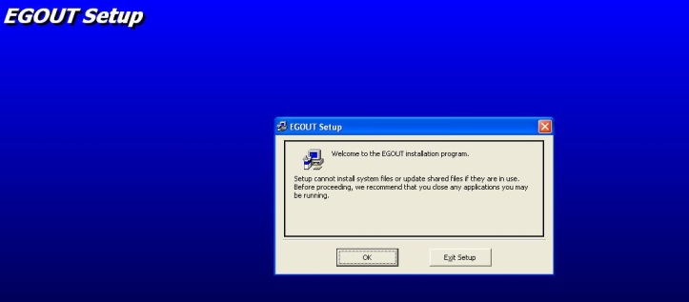
Click on the ok button
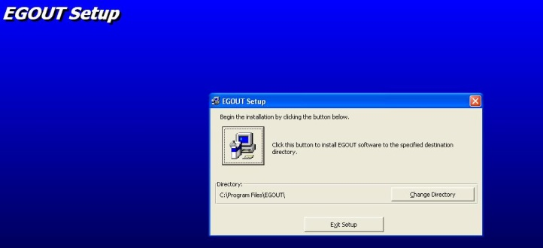
Click on the button with the setup image (top left button).
Click on Yes (to keep the existing updated file on the system)
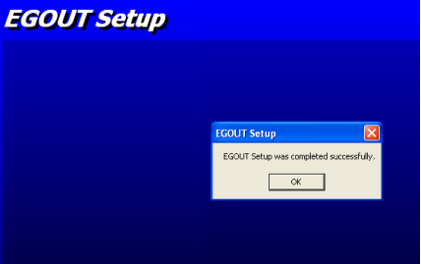
The program installation was successful.
The program executable file folder which is usually saved in a folder named EGOUT-acadxxxx (for example 2023)and its name is EGOUT.EXE, copy it and paste it on the hard drive in the desired path such as
D:\EGOUT
Run the executable file EGOUT.exe. You can make its shortcut on the Desktop for easy access.
After running the EGOUT.exe program, the program panel is displayed.
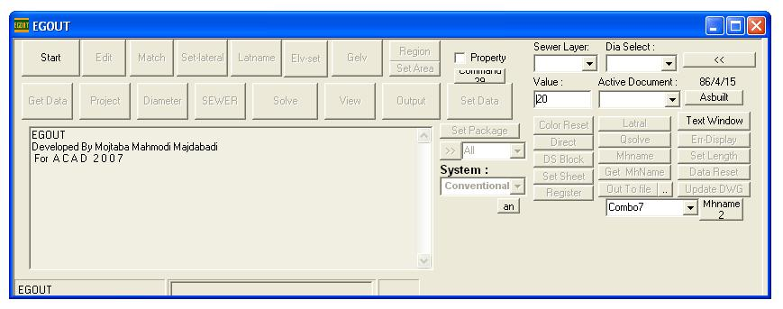
The latest version of the program works with AutoCAD 2023. Please note that the program executable file should match the AutoCAD version running on your computer, otherwise the program will give an error message when connecting to AutoCAD.
At the beginning, only the Start button is active. You first need to run AutoCAD, then click on the START button of the program after AutoCAD opens. The program connects to the active AutoCAD drawing. After connecting to AutoCAD, the other buttons become active. The connection to the AutoCAD drawing is also displayed in the program panel text box.
The EGOUT mark and a series of circles are shown in the new drawing. The program creates the layers and blocks used in the drawing.
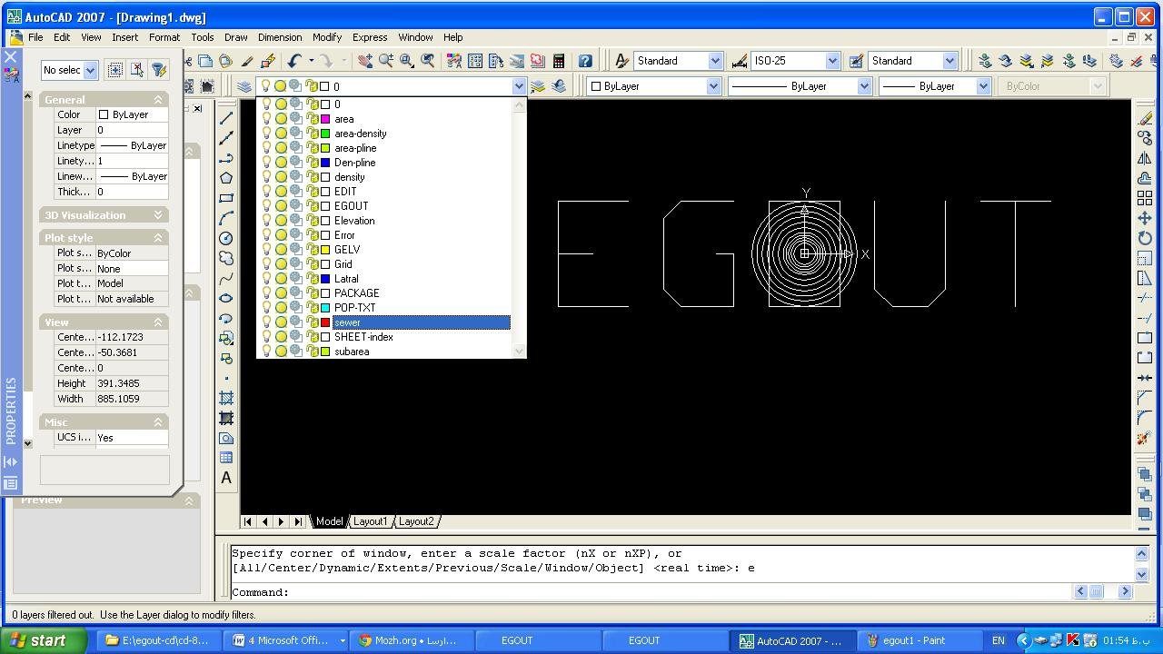
3- Drafting the sewer network plan
Note: To learn the operation of the program, it is recommended to draft 20 to 30 pipes in the form of several main and secondary branches and save it after each step. After successfully completing all design steps and getting acquainted with drafting, layering, coloring, zoning, and viewing and editing the profile on the small sample file, note the usage points and complete this text file.
1- Run AutoCAD.
2- Open the desired sample plan in AutoCAD.
3- Run the EGOUT program.
4- Click on the START button.
5- Make the sewer layer current in AutoCAD. To make the layer current, go to the AutoCAD layer cascade menu and select the sewer layer.
6- Set the drawing color to magenta in AutoCAD. To select, go to the AutoCAD color cascade menu and select color number 6 (magenta).
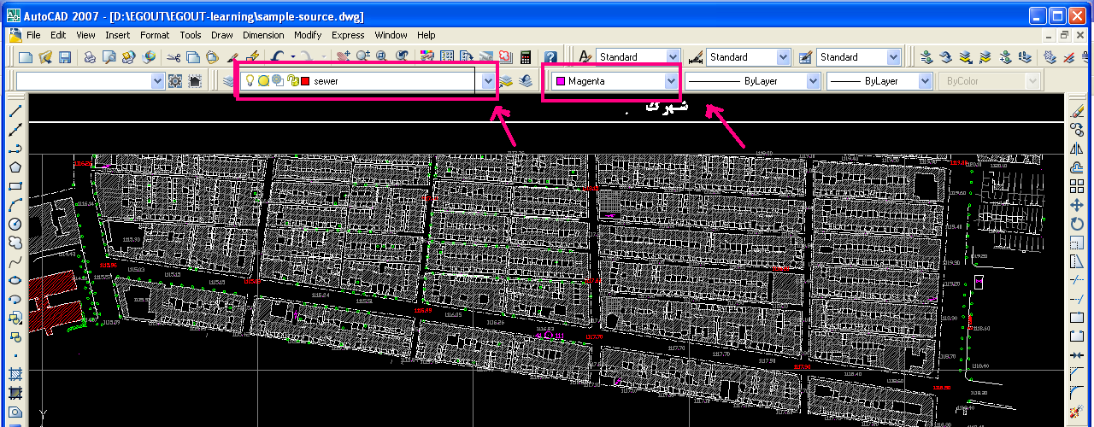
7- Draft the network plan using the line command in AutoCAD. Draft the network considering the street, alley, route change, secondary pipe connection, and pipe length. Use AutoCAD capabilities for line lengths (about 50 meters).
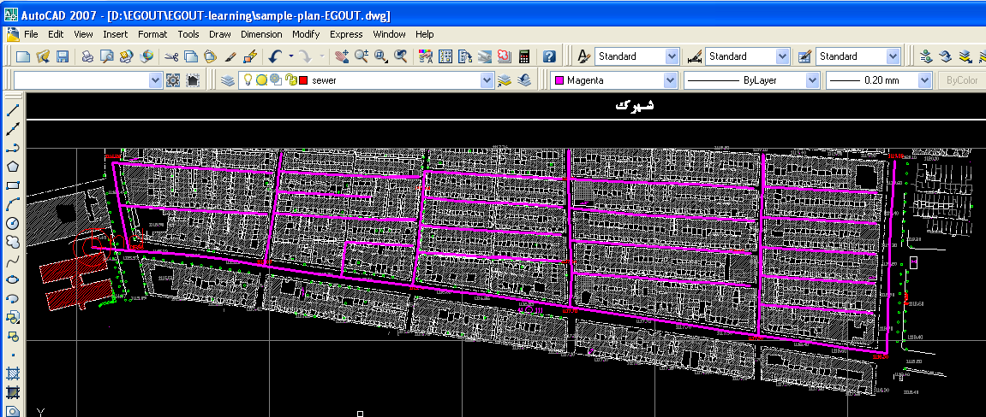
8- After drafting the network, install the endblock block (created by the program) at the sewer outlet using the insert command in AutoCAD. (The said block should not be exploded).

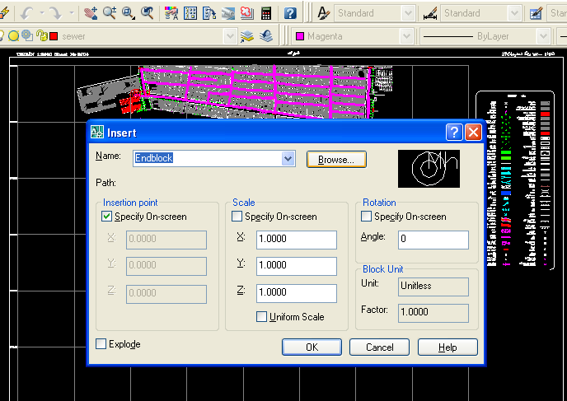

When installing the block, select the installation position at the end of the outlet line of the network and in response to the Endpoint <End> question you can press Enter or specify the outlet manhole number at this point (the default outlet manhole number is 100).
9- After drafting the network and installing the outlet block as shown in the figure above, go to the EGOUT program again and press the Start button (to connect the program to the drawing) and click on the EDIT button again on the EGOUT program.
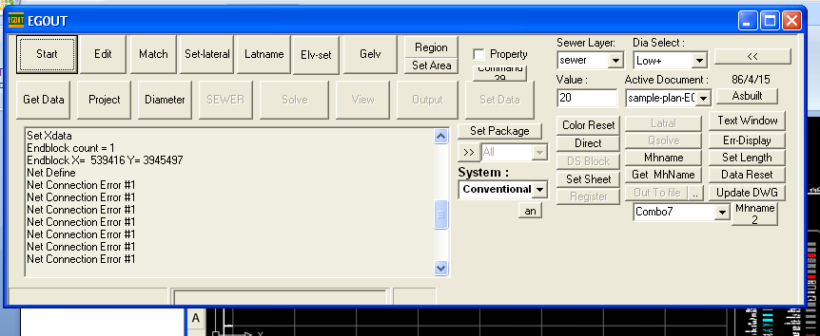
Based on the error shown, locate and identify the connection break. The drawn Error lines facilitate tracking. The first point from the outlet to the first drawn error line guides us to the connection break point. We should not worry about the number of drawn error lines because with one connection break, all the upstream lines that are not connected to the outlet will also draw an error line.
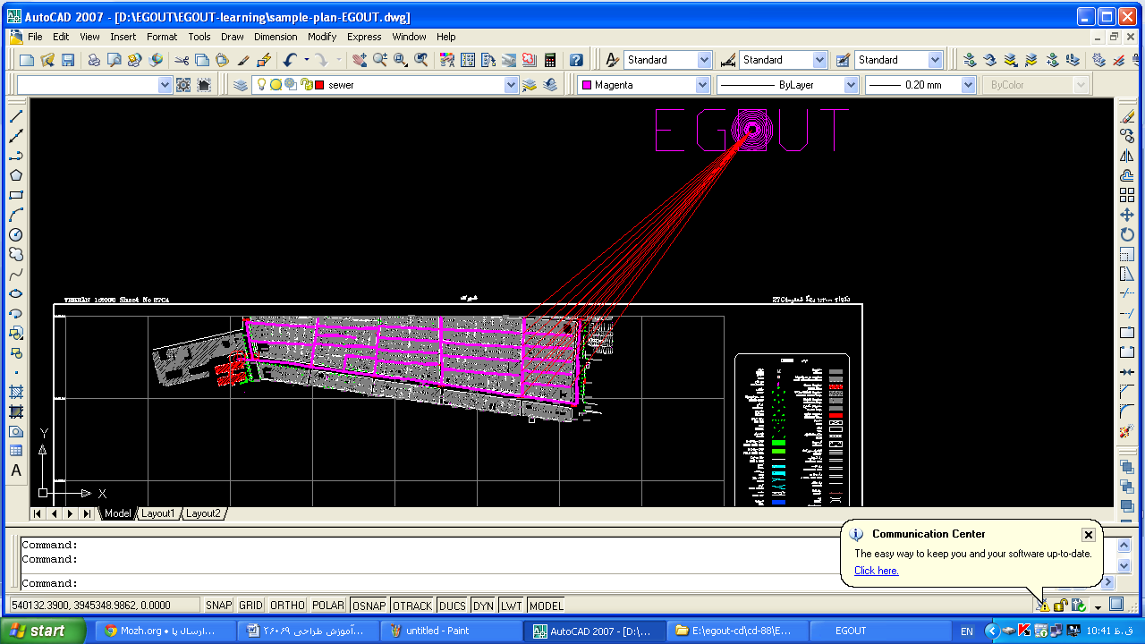
10- Based on the error shown, locate and identify the connection break
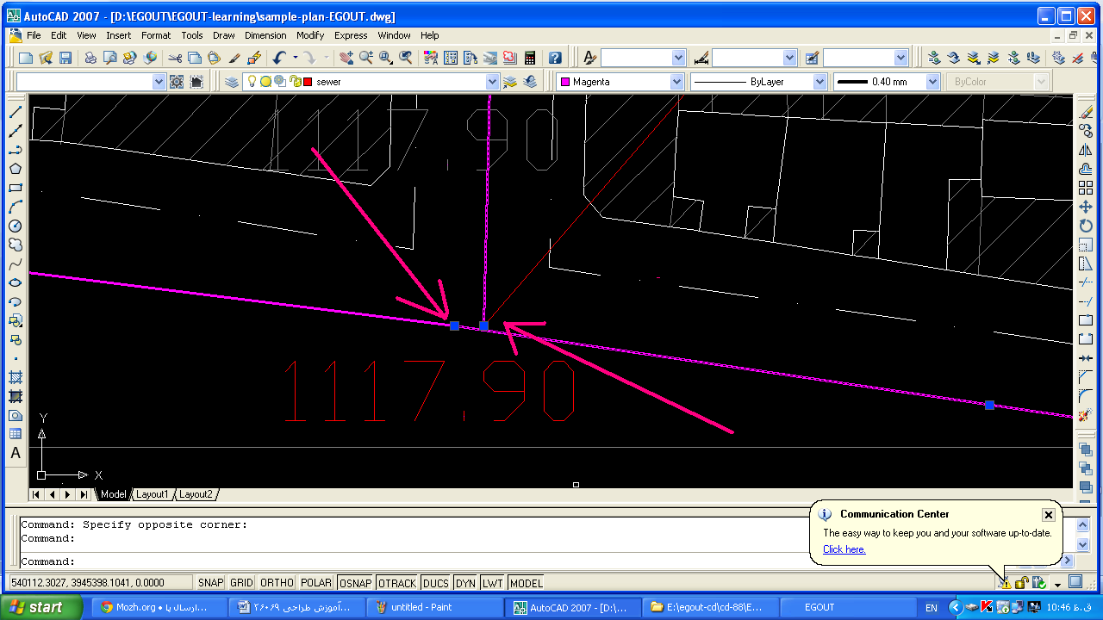
After fixing the error (making the lines end to end), click the Edit button again on the EGOUT program
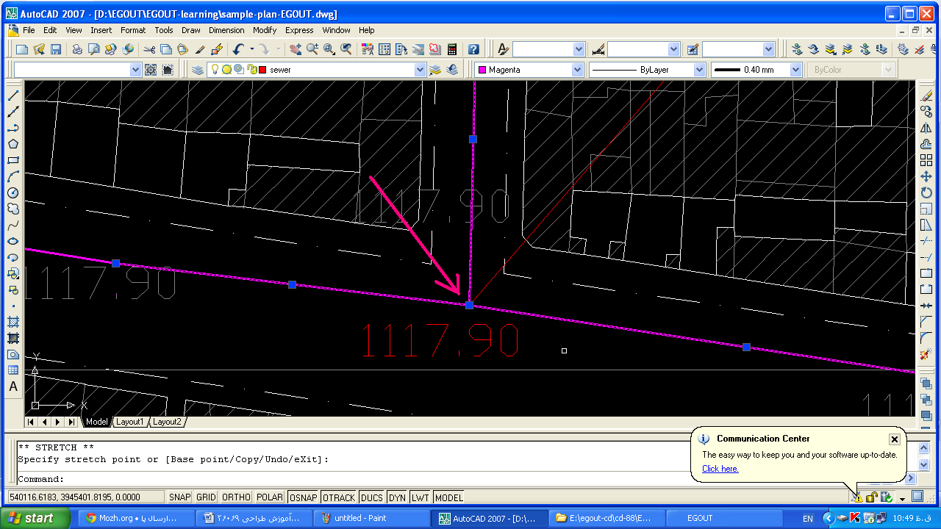
Click on the Edit button on the program. The program identifies the network. And without Error, the following message is displayed in the program's text pane:
EDIT
Active Document =sample-plan-EGOUT.dwg
Check Xdata
109 Line
Check Sewer Intersection
Set Xdata
Endblock count = 1
Endblock X= 539416 Y= 3945497
Net Define
EDIT...
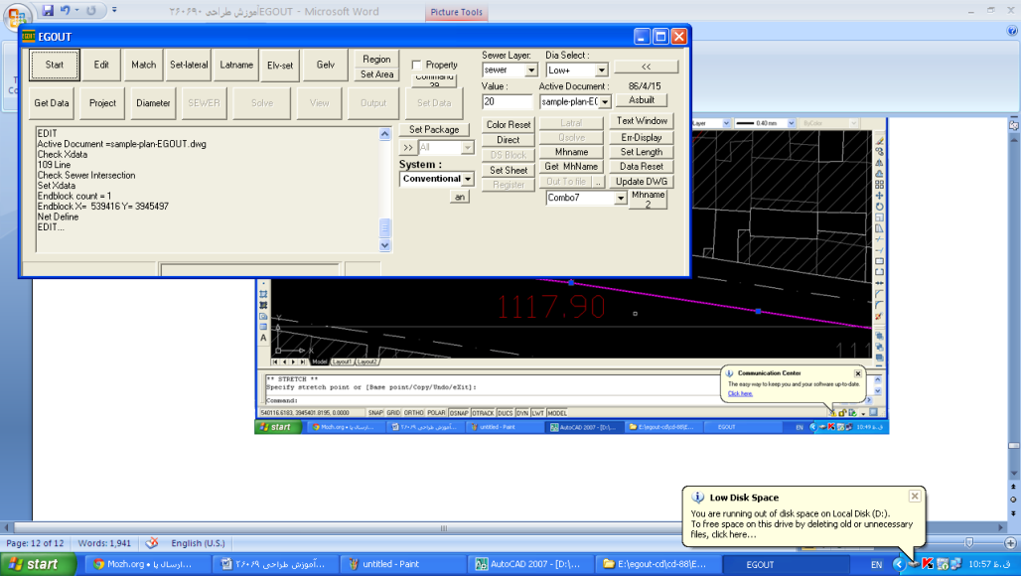
3-1- MATCH button
After drafting the sewer network plan in AutoCAD using the Line command in the sewer layer and magenta color and considering the grading and street intersections as well as the 40 to 80 meter length of each pipe line and subsequently installing the endblock block at the outlet point(s), and editing the network in terms of network identification and pipe connections to each other and connection to the outlet point were explained in the above section, refer to the previous examples, images and attachments in case of ambiguity.
1- Open the desired file.
2- Click on the Edit button. (The stages of network drafting and editing were explained before).
3- Click on the Match button.
The Match button attaches the pipe line number, upstream line number, downstream line number, tributary line numbers, and line color number in a table called Maa to the Xdata of each pipe line. (The Xdata can be viewed for each pipe line through the Express menu of AutoCAD and the Xdata list submenu).
If a pipe line is deleted from the network or a line connection is cut or the line path changes, after checking the Match address data, the program will give a Match error message in case of discrepancy with the drafted network. This is to protect the network structure and control the design process.
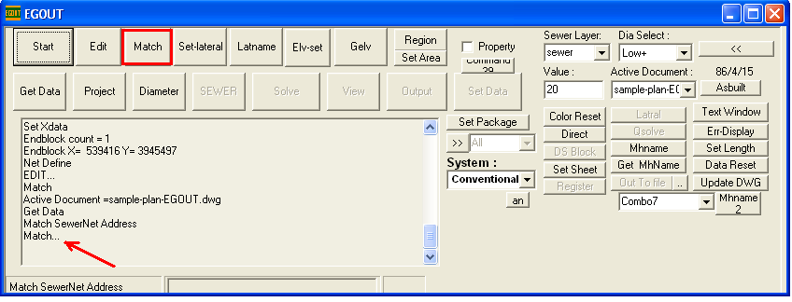
4- Network path branching
In the new version, branch coloring is done based on the longest network path using the By Len button which is below the Setlateral button.
Using AutoCAD capabilities, network branching can be determined by pipe colors. The program considers red (AutoCAD color number 1) as the main branch and yellow (2) and green (3) as semi-main branches and turquoise (4), blue (5) and purple (6) as secondary branches for branching. For branching, it is enough to just change the color of the branch heads. The network coloring is done by the program.
- Just change the color of the branch heads according to the desired main and secondary paths.
2- Click on the Setlateral button. The program performs network coloring.
3- To change the main and secondary paths, the branch colors can be reset to the branch heads by clicking the Color Reset button, then the branch head color changes can be made and click on the Set Latral button again.
Note: Network coloring must be done by the program. Manual line coloring is not identifiable for main and secondary lines for later steps.
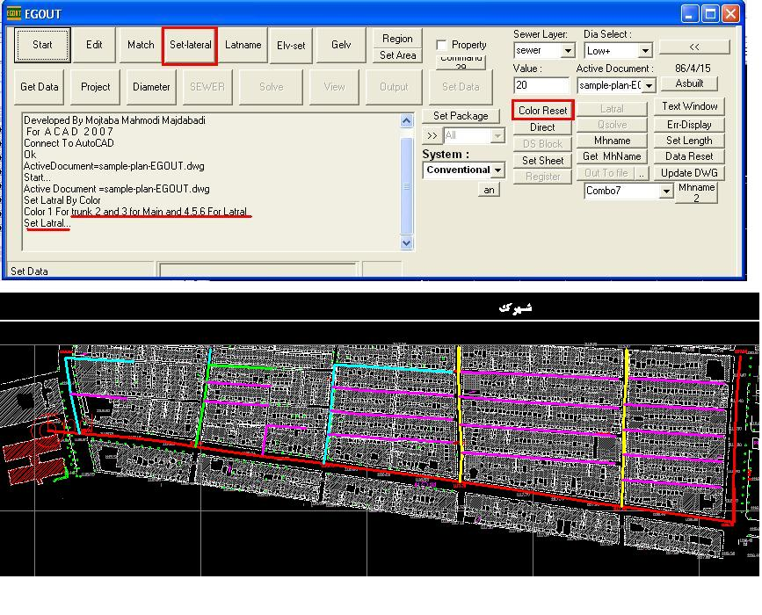
5- Naming the sewer network axes
After coloring, the axes can be named. For this, click on the Latname button. The program names them by installing the Latblock block at the end of the last network line and with the default ATTRIB *01, prioritizing the branch coloring.
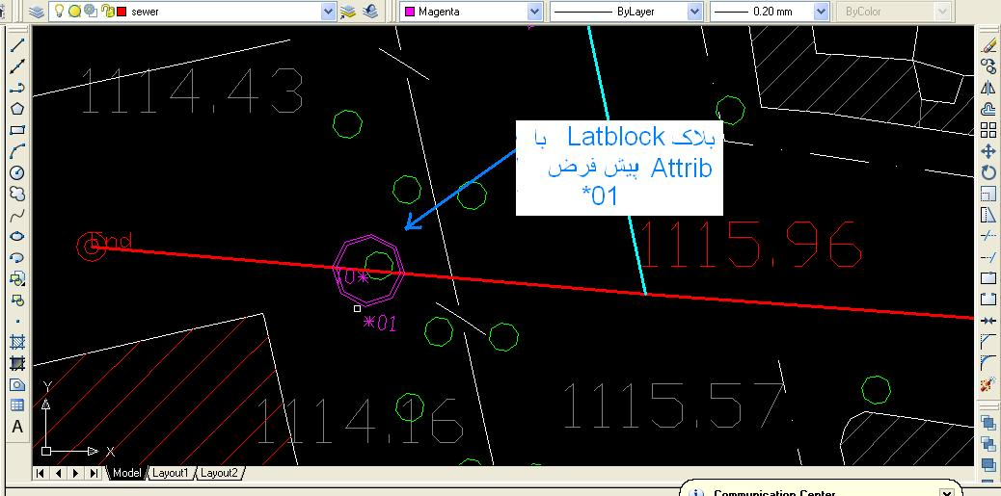
After network naming, to change the axis name, double click on its block attrib and edit it, then click on the Latname button again.
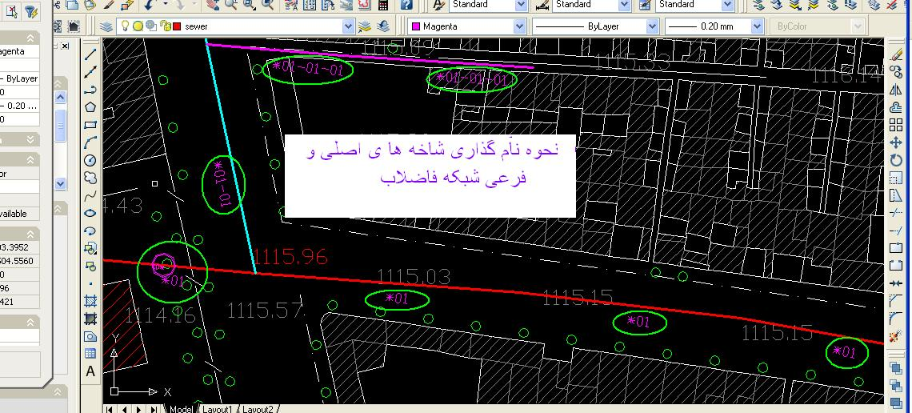
The latblock block can also be copied to the ends of other axes and its attrib can be edited by double-clicking on the block.
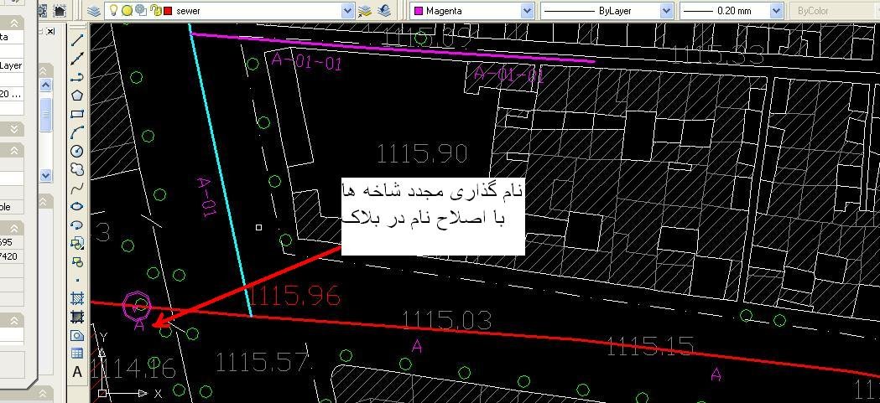
If two secondary branches leading to a manhole have the same color, it will error during naming. To fix the error, the coloring must be corrected. To reset the color to the branch heads, click the Color Reset button.

6- Numbering the manholes:
After naming the branches, the manholes can be numbered. For this, click on the mhname button. The program numbers the manholes from the end towards the branch heads. The default number is 100 which can be set as the desired outlet number in the Endblock Attrib and click on the Mhname key again.
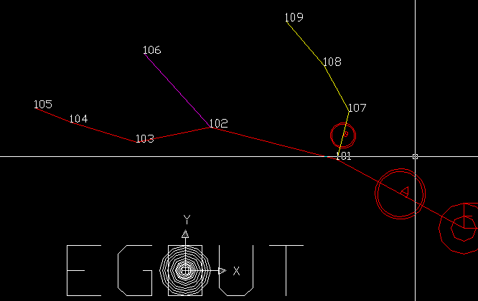
7-Elv-set elevation interpolation
Transfer all elevations to the elevation layer. Try to match the elevation insert point with its position. To do this, justify the elevations to Middle. Select them all and move them to their positions.
The default search radius is 20m which can be changed in the Value box of the main program panel.
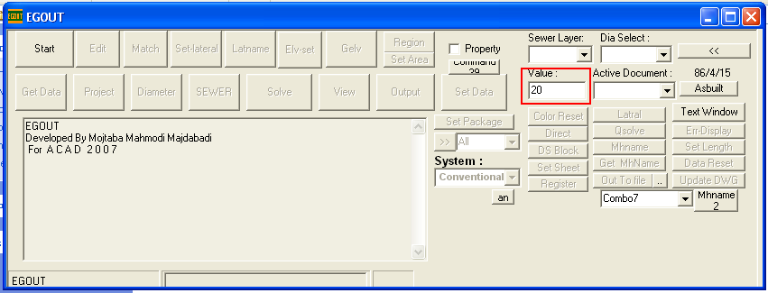
After interpolation, the number of found manholes is mentioned. Then the search radius can be increased. The interpolated elevations at the beginning and end of the lines are shown in the Gelv layer, which can be edited.
If the number of manholes with equal = 0 elevation is high, the search radius value can be changed.
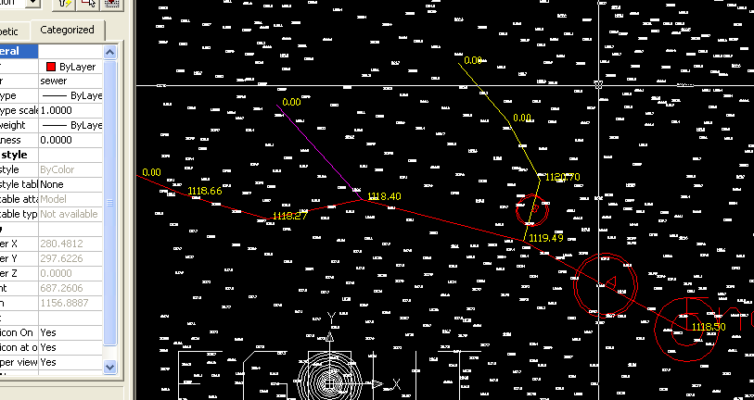
8-Gelv adding elevation to network pipes:
After interpolation, this button assigns the elevations on the pipes to the start and end z of the lines. If the start or end z of a line is zero, error line number 5 is shown. To edit the Z, the zero Gelv elevation can be Edited and click on Gelv again.
Very negative slopes and very high slopes are shown with error lines.
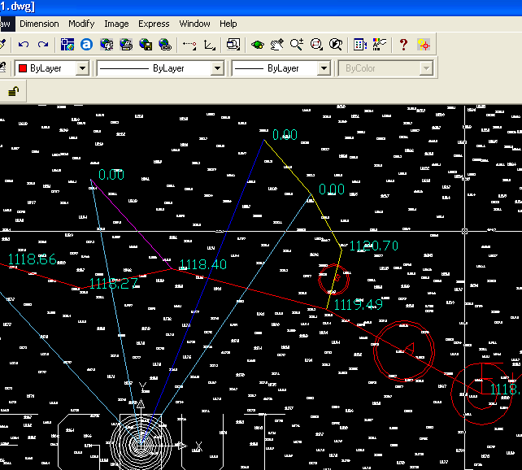
9- Region button for network zoning
The designer can draw continuous zoning lines in the Area-density layer. In this case, the Line command is used in ACAD and the lines are drawn end to end.
The network can have one general zone or according to the need and accuracy of the plan, have several sewage collection zones. If the designer wants to define the population density as well, define the density amount as D1 = ?? and D2 = ?? (for density) and P1 = ?? and P2 = ?? (for population) in the density layer inside each drawn zone. The mentioned texts must be placed inside each drawn zone and their layer must be density. The errors in this step include the intersection of zoning lines or lack of line connection. If there is no pipe line in a zone, Error 11 color is shown.
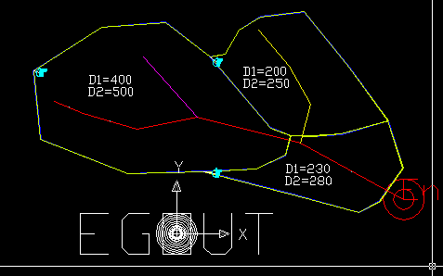
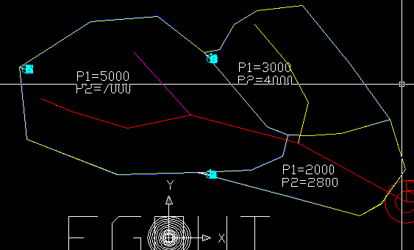
10- Get data button
At this stage, for sewer network design, the information created in the map preparation process is extracted and used for design. Before network design calculations, the information must be extracted from the drawing data using the Get data command.
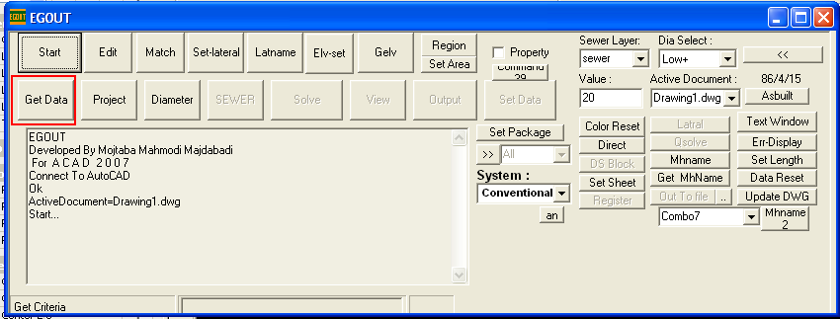

- Project button
The design basis data is entered in the Project window.
In this window, the project title, criteria, population criteria, infiltration criteria, inflow criteria and runoff are specified.
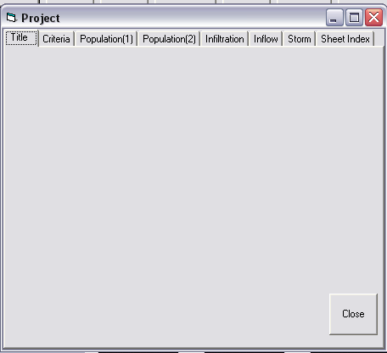
11-1- Project specifications
The project title, designer and date are entered in the Title window.
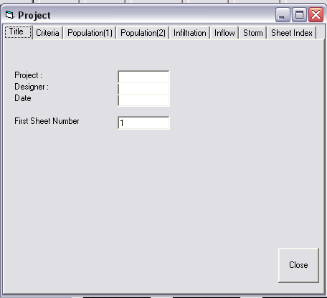
11-2- Design Criteria window
In this window, the main criteria of the project including per capita wastewater in liters per person per day (LPCD) at the beginning and end of the plan, the percentage of network connection at the beginning and end of the plan, groundwater level, infiltrating waters as a percentage of wastewater peak, minimum soil cover over the pipe, minimum velocity required for flushing, minimum acceptable H/D to bring the lines up to speed, hydraulic loss in manholes in meters, variability of Manning coefficient and limiting the peak coefficient to a maximum number are received.
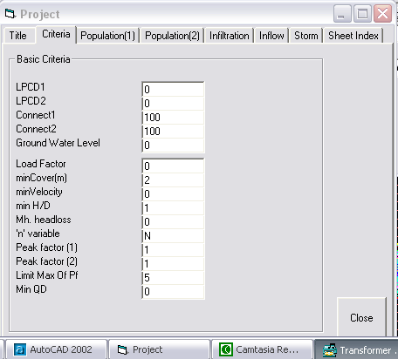
11-2-1- Wastewater generation per capita
1- LPCD1
Wastewater per capita at the beginning of the plan is received in liters per person per day. The wastewater per capita at the beginning of the plan can be left undefined. In this case, the flow rate, velocity and other hydraulic parameters will not be calculated. The per capita value at the beginning of the plan must not be greater than the per capita at the end of the plan.
2- LPCD2
The wastewater per capita at the end of the plan is received in liters per person per day. If the wastewater per capita at the end of the plan is not defined, the domestic wastewater flow will not be calculated.
11-2-2- Network connection percentage
The network utilization percentage can be determined at the beginning and end of the plan. The program takes into account the network connection percentage in hydraulic calculations.
11-2-3- Inflow amount
If there are unauthorized connections in the network, the water inflow to the network can be introduced as a percentage of the maximum flow rate. This amount can be zero, 10, 20 or even 100 percent.
11-2-4- Groundwater level
To calculate infiltration in methods where the length and diameter of the network are the calculation criteria, the groundwater surface elevation can also be involved. In this way, there is a groundwater level for the above criteria and the maximum infiltration amount is considered for the condition that the pipe is below the groundwater level for calculating infiltration. If the infiltration criterion is not based on the length and diameter of the network or the groundwater is very low, no elevation can be specified for it.
11-2-5- Minimum velocity
In this window, the minimum velocity is used as a parameter to control the initial and final velocities of the plan pipes. In this way, if the initial or end velocity of the pipe line is less than the defined velocity value, the program will increase the line slope so that the flow velocity reaches the minimum mentioned. However, if the wastewater flow is low, the minimum velocity may not be achieved by increasing the slope. Another control criterion will be the H/D ratio. If the pipe line velocity is less than the defined minimum and the H/D ratio is greater than the defined value, the program will increase the slope. Otherwise, it will disregard bringing the line up to speed and the said pipe line will need flushing.
11-2-6- Minimum H/D
As explained for the minimum velocity, the H/D parameter must also be considered in order to bring the flow velocity to the desired minimum velocity and use it as a control factor to increase the slope and depth of the pipe lines. In each project, the network can be solved for different minimum velocities and H/Ds and their effects on the network depth can be examined, and based on that, the appropriate H/D value can be selected. Normally, H/D can be considered 0.5 and then the network can be solved for H/Ds of 0.1, 0.2, 0.3 and their effects on the network can be examined.
11-2-7- Manhole hydraulic loss
Due to the change of flow cross section, path change or slope change in manholes, we will have local losses. In networks with high pipe slopes, the manhole loss can be neglected because the high slope will eliminate the created loss, but for areas with minimum slopes, the hydraulic loss can be defined between 0.00-0.10 meters.
11-2-8- Manning coefficient variability
If the letter Y is entered in front of the phrase, the program will calculate n according to the calculated H/D in hydraulic solution and will calculate the full flow rate and hydraulic parameters based on that. If N is entered, the program will consider the introduced Manning coefficient for all conditions in the calculations.
11-2-9-Minimum flow rate
In industrial sewage network design, the minimum design flow rate can be introduced as Min QD.
11-3- Population calculation criteria menus for beginning and end of plan (1 and 2)
The population or population density data is received in the Sewer window, but the calculation criteria are received in these menus.
11-3-1- Density
In this case, the population will be calculated by multiplying the density by the cumulative area of the pipeline. The population density of each pipeline is received in the Sewer window.
11-3-2- Population
In this case, the population of each pipeline is received in the Sewer window and the program will calculate the cumulative population.
11-3-3- CURVE
In this case, the population is calculated through the density curve. The density curve is similar to the infiltration curve. It is usually used to ensure the capacity of secondary and semi-main lines to cover the population resulting from local and unforeseen density. At low levels (10-5 hectares), the maximum density and approximately the saturation density of the city will be used. The curve is used for larger areas. The density amount for the total city area will be the average density. The curve coordinates are introduced as follows:
X1 = The area which is less than that, the maximum density is considered for population calculation.
Y1 = Maximum density
X2 = Total city area
Y2 = Average city density
11-3-4- Total Population
In this case, the cumulative population of each pipeline will be received in the Sewer window. If we have the cumulative population of each pipeline, the network calculations can be performed based on the introduced cumulative population.
11-4- Infiltration and Inflow windows for combined networks
The infiltration and inflow calculation method is determined.
11-4-1- Cubic meters per kilometer of pipe length per day
Using this criterion, the program multiplies the pipe length by the minimum amount (if the pipe is above the groundwater level) or the maximum amount (if the pipe is below the groundwater level) and adds it to the infiltration of the upstream lines. In this case, the entire network pipes must be designed because the amount of infiltration depends on the introduced network length.
11-4-2- Cubic meters per kilometer of pipe length and pipe diameter centimeters per day
In this criterion, the pipe diameter is also effective in calculating infiltration. If the pipe is below the groundwater level, the maximum amount is used and if the pipe is above the water level, the minimum amount is multiplied by the length and diameter of the pipe and added to the infiltration of the upstream lines. In this criterion as well, infiltration will be calculated based on the introduced network length and diameter. If only the main lines are designed, the calculated infiltration will not be accurate.
11-4-3- Infiltration curve
In this case, infiltration is calculated according to the coordinates of the introduced curve and the cumulative area of the pipe line.
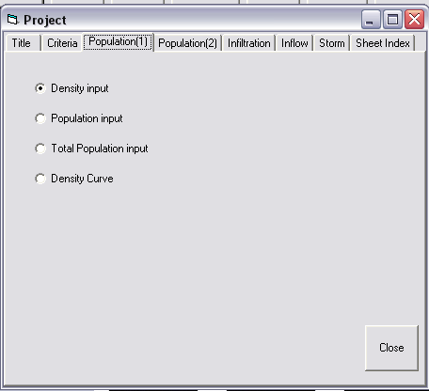
A sample infiltration curve introduced in Metcalf's book is shown in the figure. In curve A of the figure, if the area is less than 5/40 hectares, the infiltration amount will be 14 cubic meters per hectare per day, and if the area is less than 5/40 hectares, the infiltration amount will be 14 cubic meters per hectare per day, and if the cumulative area of the basin is between 5/40 to 5000 square meters, infiltration is obtained from the curve, and if the area is more than 5000, the infiltration amount is * cubic meters per hectare per day. The program receives the coordinates of two points of the curve as Y1, X1 and Y2, X2, where X1 is the first area (e.g. 5/40), Y1 is the infiltration amount (14), X2 is the second area (5000) and Y2 is the infiltration amount (1/3). If the infiltration amount is a fixed value (e.g. 8 cubic meters per hectare per day) for the area, you can define Y1=8, X1=1 and Y2=8, X2=5000.
11-4-4- LPCD
If infiltration is to be introduced as infiltration per capita, the LPCD option can be used. In this case, infiltration is calculated by multiplying the cumulative population by the per capita amount.
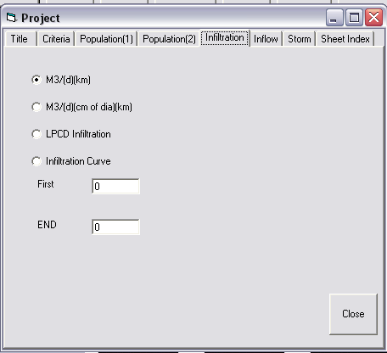
11-4-5- Surface runoff data window for combined networks
A combined collection network collects all or part of the surface runoff along with domestic wastewater. Domestic wastewater flow calculations are performed based on the defined principles, but other principles and parameters are received in this window for calculating surface runoff.
In general, urban surface
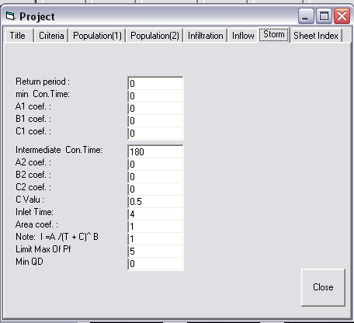

12- Diameter window
The program needs to know the economic diameters to be used for selecting the pipeline diameter. It receives the diameters that can be used in network design in this window. In this window, the diameters are introduced in order from small to large. The hydraulic parameters and the purchase and installation cost of each pipeline and the manhole installation cost are received in this same window.
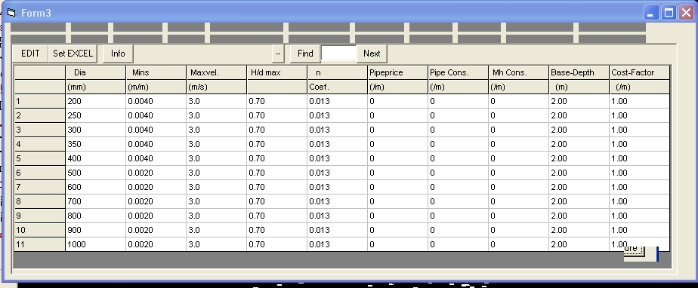
In the first column, the inside diameter of the pipe in millimeters is received.
In the second column, the minimum slope related to this diameter is introduced, which the program will not select slopes less than this for the pipelines.
In the third column, it receives the maximum velocity under full flow conditions, and if the pipeline velocity becomes higher than this, it will reduce the pipeline slope.
In the next column, the maximum H/D ratio can be defined for each diameter. In this case, if the calculated H/D in a pipeline is greater than the introduced value, it will select the next diameter. The purchase price per meter of pipe length, the installation cost per meter of pipe length, and the manhole installation cost per meter of depth are introduced in the subsequent columns.
13- Sewer window
The input network data prepared through the plan map preparation process is numerically visible and editable in this window. The manhole names, ground elevations, pipe lengths, areas and populations, amount, minimum cover, diameter, slope, incoming pipe bottom elevation, and line specifications are shown in this window.
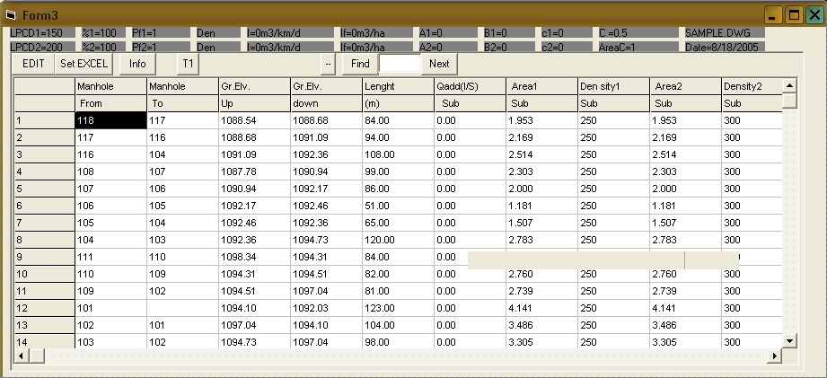
Note: The pipe length values ​​cannot be changed in this window.
The designer can change the data values ​​except for the length. It is necessary to control the total zoning areas with the plan area before solving.
The line characteristics in terms of existence, defined slope (S), defined diameter (D), and lifting pumping (L) are introduced in the Status column. Introducing these features on the profile in the View window is simpler.
13-1- Name of beginning and end manholes
The manhole name can be introduced to the program in letters or numbers. In the first column, the name of the starting manhole and in the second column, the name of the ending manhole is introduced. The program completes the second column based on the name of the starting manhole. The user can change the manhole name in the first column. Also, the names of the network outlet manholes can be changed in the second column.
13-2- Ground elevation of beginning and end manholes
In the third and fourth columns, the ground elevations of the starting and ending manholes are shown. The program extracts these elevations from the Z coordinates of the lines drawn in the plan.
13-3- Pipe length
In the fifth column is the pipe length in meters, which the program extracts from the length of the lines drawn in the PLAN and is not changeable in this window.
13-4- Extra inflow
In the next column, the extra inflow to the pipeline can be introduced in liters per second. Extra inflow refers to the flow related to industries, development areas or other wastewater inflows that enter the network at a specific amount.
If the wastewater flow of the network lines has been calculated, the flows can be introduced in this column and the design calculations can be performed.
13-5- Basin area at the beginning of the plan
The program receives the wastewater collection basin areas at the beginning of the plan separately. Some areas (such as city development areas) may be zero at the beginning of the plan. If the network has been zoned by the program (Region), the basin areas are shown in this column, which can be edited.
13-6- Population density or population at the beginning of the plan
In the next column, the population density or the line population is received according to the selected population calculation criterion in the Project menu. If the density calculation criterion is selected, the population density is received in this column, and if the partial population criterion is selected, the partial population of each line is received in this column, and if the cumulative population criterion is selected, the cumulative population of each line must be entered in this column.

13-7- Basin area at the end of the plan
In this column, the partial basin area of each pipeline is received. The total basin area is calculated by the program. The basin area is in hectares. If the network has been zoned by the program (Region), the basin area of each pipeline, etc. is shown in this column, which can be edited by the user.
13-8- Population density at the end of the plan
According to the population calculation criterion selected in the Project menu, density, partial population or total line population is received in this column.
13-9- Diameter
The pipeline diameter can be received in the Diameter column. The designer can leave this column blank for the diameter to be calculated by the program. If necessary, such as defining an existing pipeline or specifying the desired diameter by the designer, the diameter can be introduced in this column.
13-10- Slope
The pipeline slope in m/m can be introduced in the Slope column. If the slope is introduced in this column, the program will calculate the pipe line slopes. If the data file has been run or saved before, the previously calculated slopes are shown in this column.
13-11- Minimum soil cover over pipe
In this column, if necessary, the soil cover over the pipe can be introduced for each pipeline. If the soil cover is not introduced, the program will consider the amount defined in the Basic Criteria window.
13-12- Inv.EL (Pipe bottom elevation)
If the network has been solved by the program, the bottom elevation of the beginning of the pipe is shown in this column.
13-13- STATUS
In this column, special characteristics of each pipeline can be defined. If the pipeline is existing, it can be indicated to the program in this column with the letter E. If you want to also introduce the Manning coefficient of the existing pipeline, enter the Manning coefficient after the letter E. (e.g. N.016)
While the existing pipeline is not defined, the program will draw the profile based on the defined soil cover and introduced slope and diameter.
If we want the program to consider the pipeline slope as defined, in other words, take into account the slope intended by the designer without change in calculations, the letter S can be entered in the STATUS column. In this case, the specified slope is considered as such. In displaying the longitudinal profile, the words SDF (Slope Defined) are seen above the line.
If we want the program to consider the pipeline diameter as the defined diameter, the letter D must be entered in this column. In this case, if the defined diameter has the capacity for flow greater than the pipeline wastewater flow according to the slope, it will consider the defined diameter. The words (DDF) are seen in the profile display, meaning the defined diameter.
If both diameter and slope are defined, SD or DS can be entered in this column. If a specific Manning coefficient is desired, it can be introduced in this column as Nnnn, where nnn is the desired Manning coefficient. (e.g. N.013)
If the infiltration from the upstream network enters this pipeline (review cases where the infiltration calculation criterion is based on network length or network length and diameter. The sewage network upstream of the network is designed in other files and enters a line in this file), the letter I followed by the infiltration amount in liters per second should be introduced in this column (e.g. I=32.4)
If we want the beginning manhole of the pipeline to be a lifting pumping station, the letter L is entered in this column. In this case, the program will calculate the pipe depth based on the minimum soil cover over the pipe.
14- Solve button
Network design calculations are performed using this button. In case of incomplete input data or duplicate manhole numbers and pipe elevation mismatch, errors and warnings are displayed.
15- Set data button
Using this button, all design operations and applied changes are transferred to the network plan, and on the plan, manhole numbers, branches, depth, coordinates, depth and slope are also inserted in different layers.
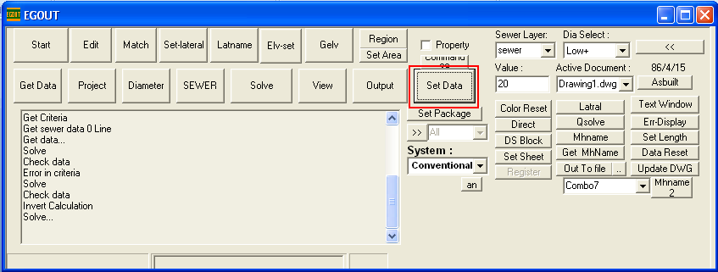
16- View button
Using this button, a window opens that displays the network longitudinal profile. The network pipelines can be viewed in this window and necessary changes can be made if needed:
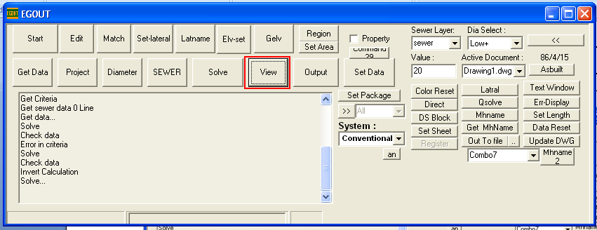

Panning is done by holding down the left mouse button and moving on the window.
16-1- Selecting a pipeline and making changes
Each pipeline can be selected by right-clicking on the window, which is shown in blue.
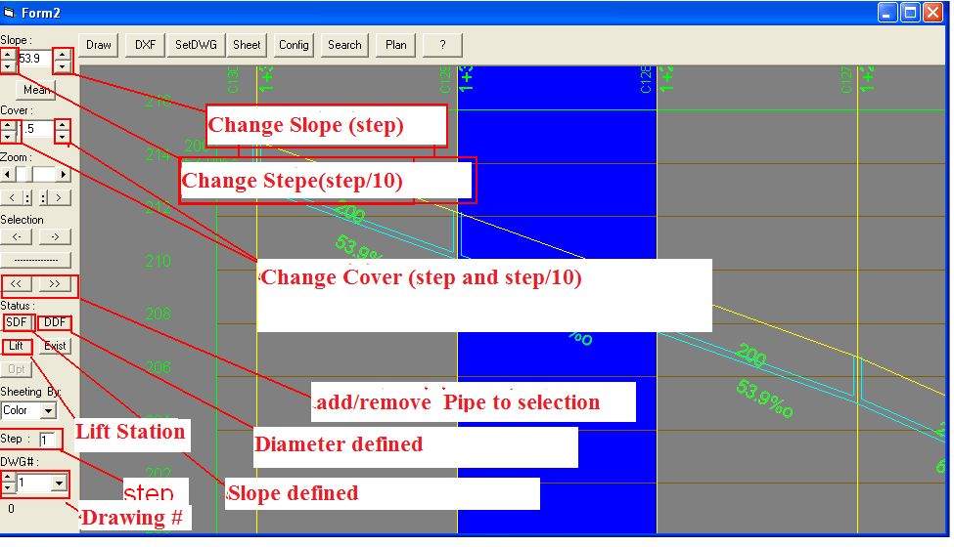
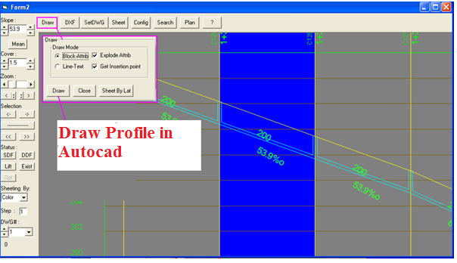
The specifications of the selected line can be changed in the sidebar tools. The displayed line slope can be changed using the buttons. The slope can also be changed using the F3 and F4 buttons. The cover amount on the selected pipe is visible and changed using the buttons next to it. Using the >> and << buttons, several lines can be selected or removed from the selection set simultaneously.
If a specific slope is desired by the designer, after making the change, the desired pipe must be made SDF (Slope Defined) using the SDF button. In this case, this slope will be maintained in subsequent network solutions.
Drawing the profile in AutoCAD:
Using the Draw button and opening the drawing window, the longitudinal profile can be drawn in the AutoCAD environment if there is a lock or registry.
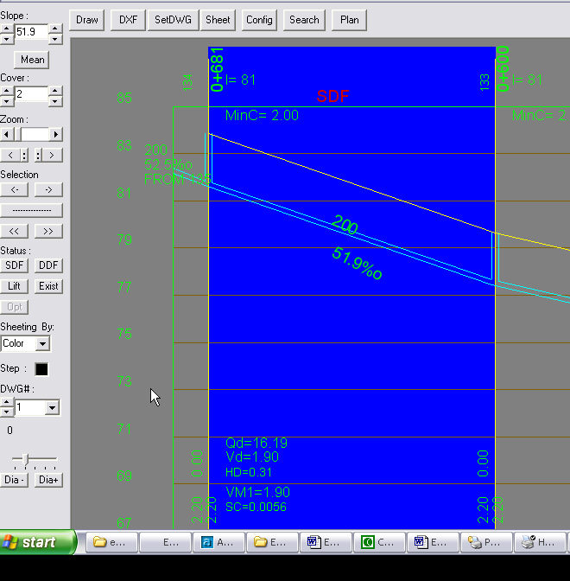
Using the F2 button, the size of the selected pipe can be increased by one size. In this case, the pipe will be DDF (Diameter Defined). By pressing the D key, the DDF attribute of the pipe is removed and the calculated diameter is considered. Using the F6 and F7 buttons, the minimum cover can be decreased or increased. Using the F8 button, the search window can be activated. In this case, all lines pass through the two specific filters of this window. In the first filter, provided that the second filter

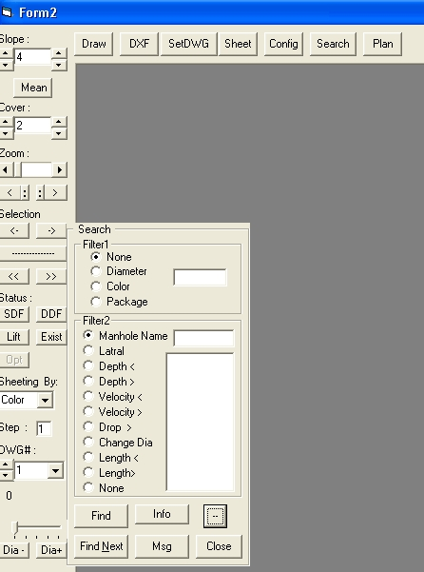

The menu buttons at the top of the View window are as follows.
- AutoCAD profile drawing window
- DXF button to create DXF file from current profile sheet (in case of having a lock or registry)
- set DWG save slope changes, DXF-SDF, or pipe slope and depth changes on the plan
- sheet adjust map sheeting based on A1, A2, A3 map frames or define drawing length
- config window to configure profile display and define profile table
- Plan button to display selected pipe line on AutoCAD plan
