EGOAS help for Profile drawing
1-Setup Program
1-1-In EGOUT-Setup folder run setup.exe

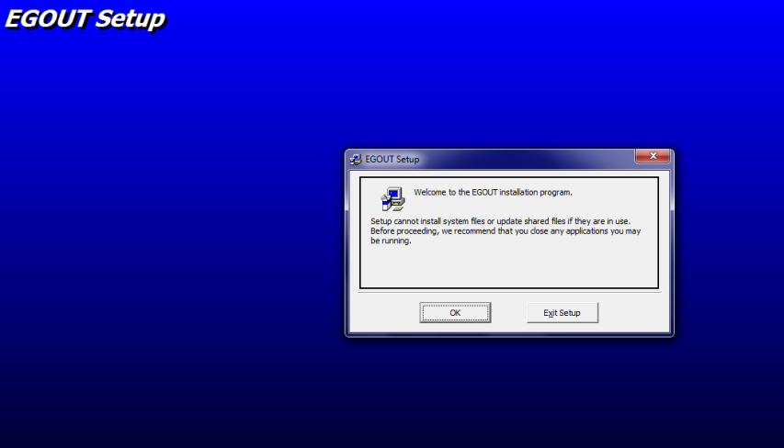
2-Press setup key
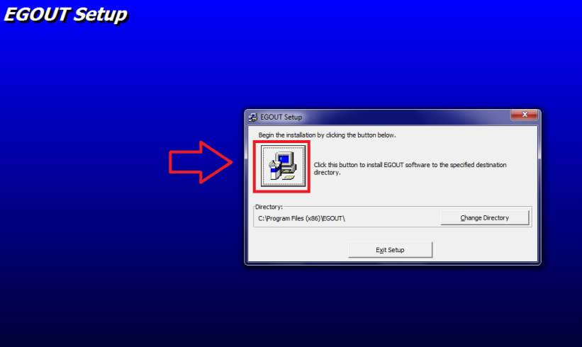
3-Press Yes key for keep systems files
4-Go to Setup successfully
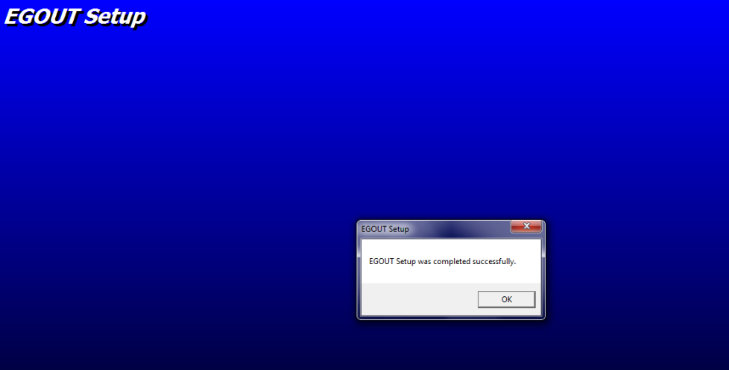

5-copy EGOAS.exe on hard disk for example “E:\EGOUT\EGOAS.exe”
6-Run EGOAS.exe
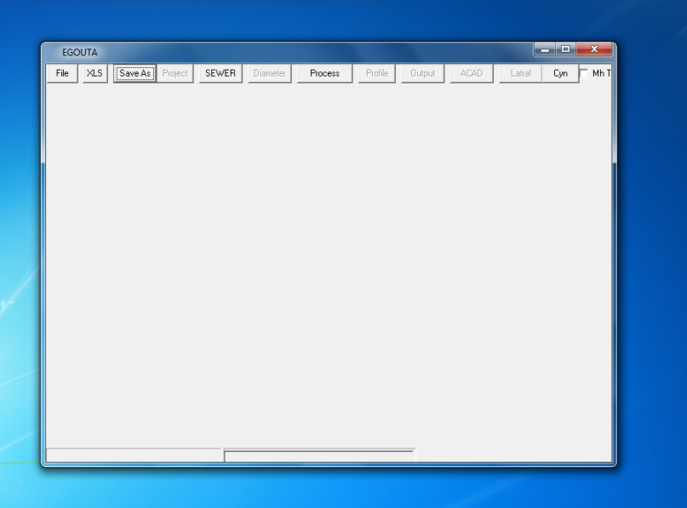
7-Run Excel and open sample.xls(program will read Excel Active sheet data)
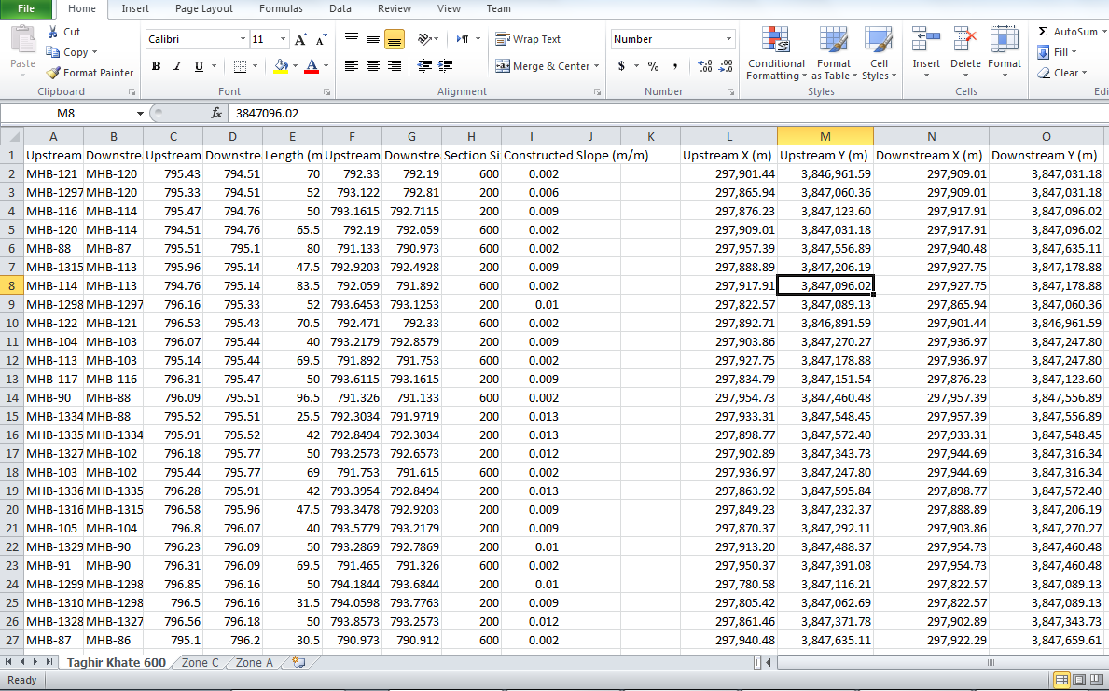
8-press XLS on menu
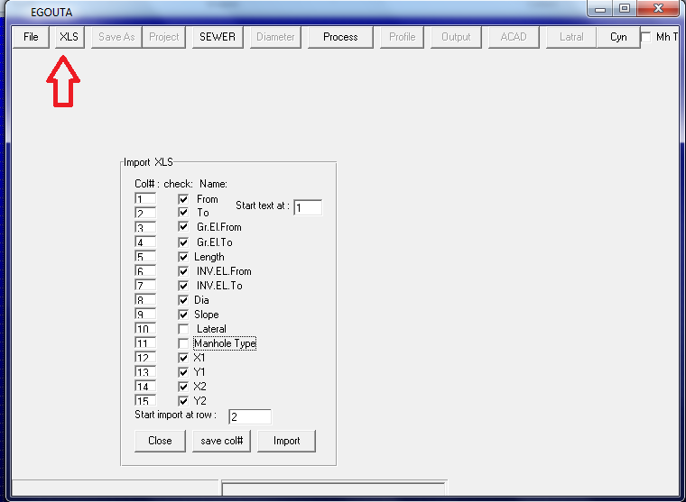
9-Check mark your data read form Excel via data sheet col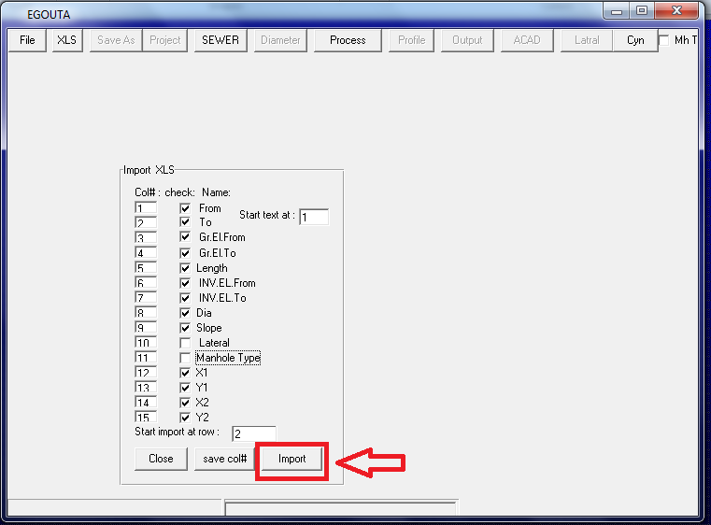
10-# then press Import key
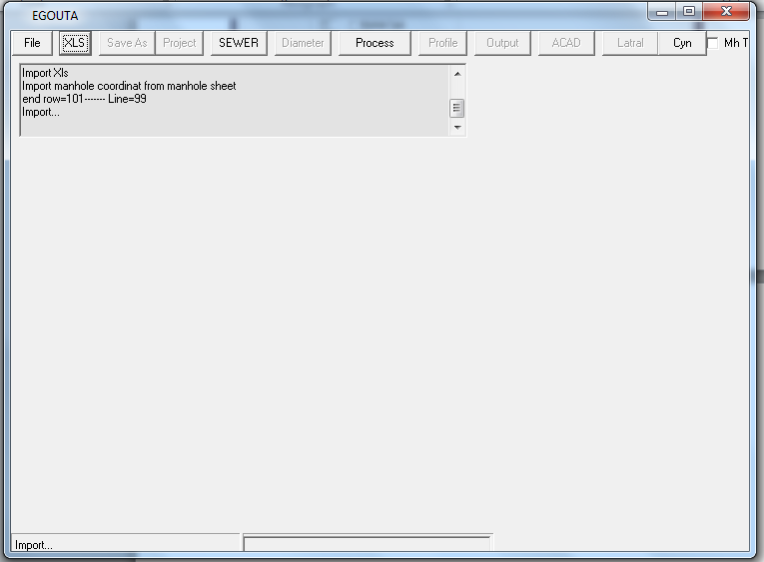
11-Press Process key on menu
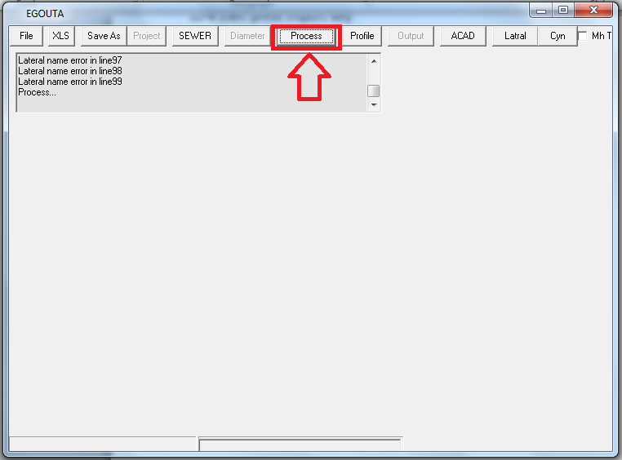
12-Press Profile key on menu
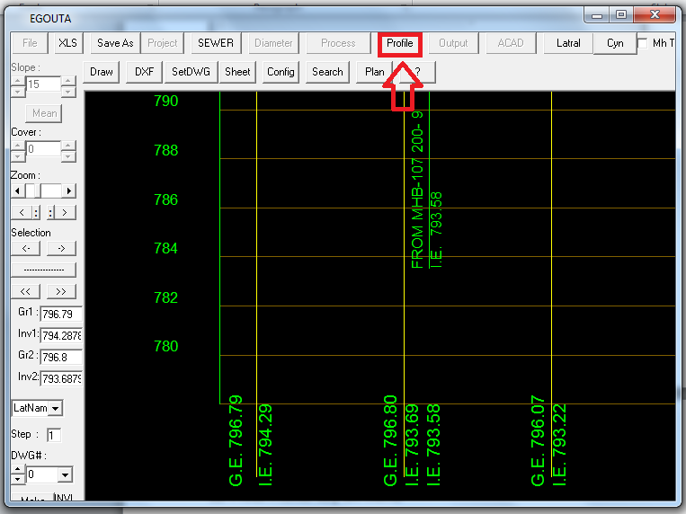
12-change Zoom of view
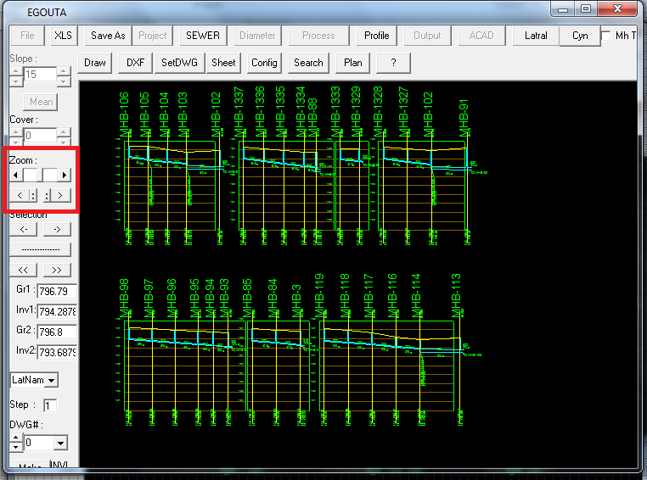
13-Press Draw key for draw in ACAD
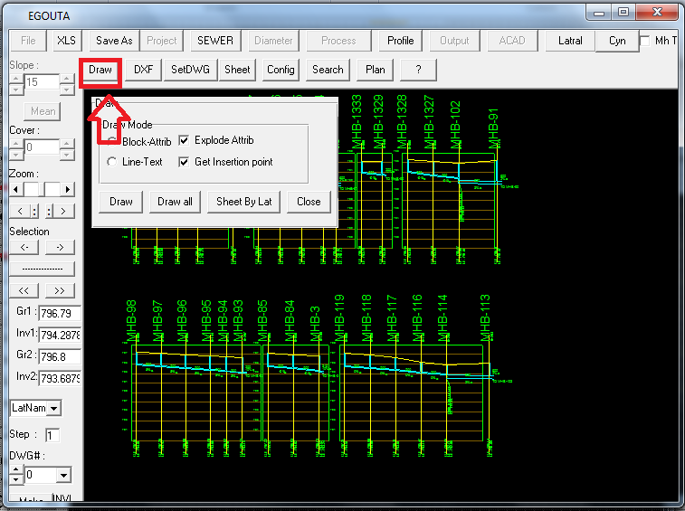
15-for draw in Acad press Draw in tab menu (this action need Registry)
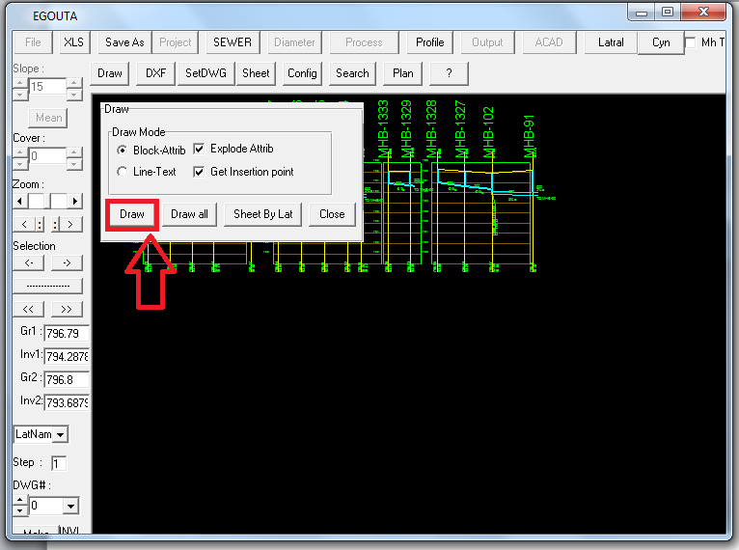
16-for Registry press Register
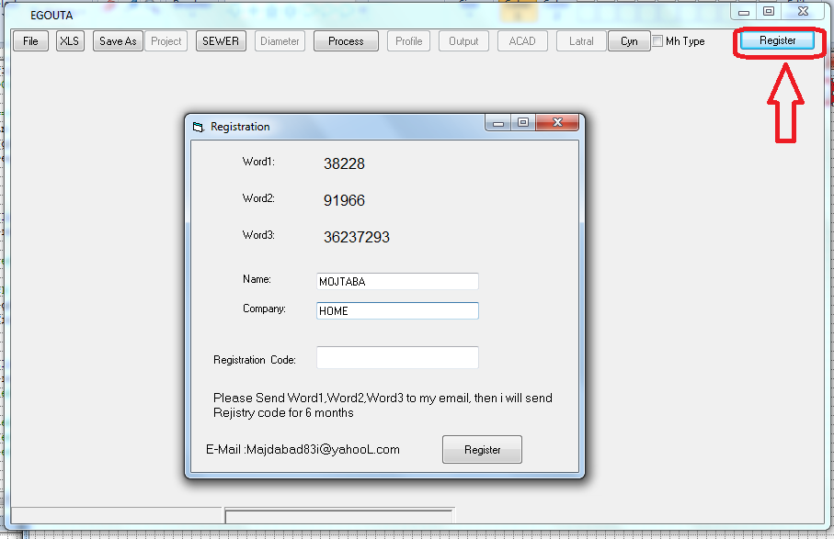
17-send Word1,Word2,Word3 for free 6 months trial to majdabadi83@yahoo.com
18-If registry is Ok then Open ACAD2013
19-for draw in Acad press Draw in tab menu
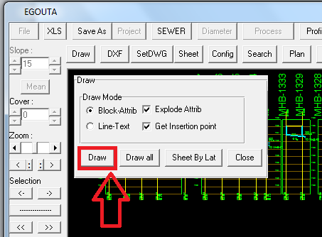

20-Enter insertion point in ACAD window
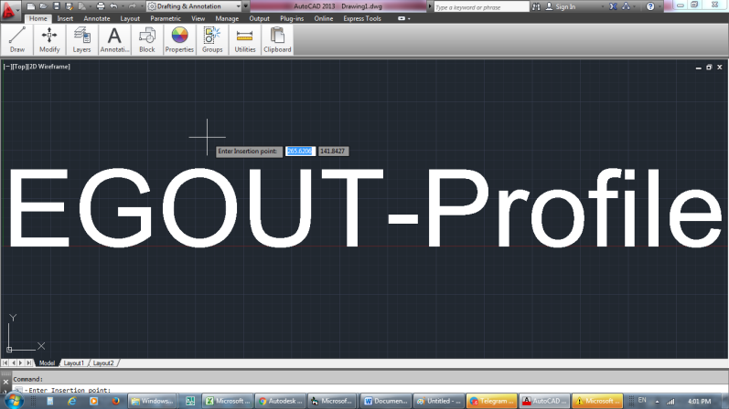
21-Profiles will be draw in acad window
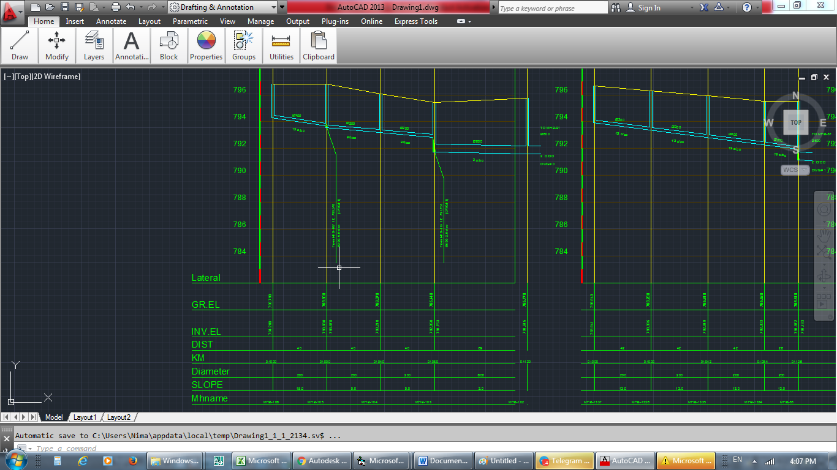
ENJOY WITH EGOUT SOFTWARE!
Thanks
Majdabadi

